Software Engineer Assessment

You have been tasked to build a weather app in a decoupled architecture. The frontend will be implemented in NextJS and theAPI/background will be implemented in the latest version of Laravel



You will get your weather data from <https://openweathermap.org/api>. Please make familiar with OpenWeathermapAPI before writing any code. If you need an API key please generate a free one after signing up.

| **Frontend Requirements** | **Backend Requirements** |
| --- | --- |
| 1. Use NextJS and Typescript 2. Implement Components with [RippleUI](http://ripple-ui.com) components from Tailwind CSS 3. Implement AJAX requests using the JS fetch API | 1. Use latest Laravel 2. Implement API only. No blade views are needed 3. Feel free to use any HTTP client you prefer 4. Do not implement API Security an open access API is okay for this demo |

**Instructions**

1. Remember, there is no wrong answer here. This test is designed to assess your approach to software design.
2. Extra points will be scored for demonstrating understanding in advance programming features like: type safety,proper commenting, Github commit messages and code elegance.
3. You will be scored on the visual appeal of your app.
4. We welcome improvisation. Weather is not explained well, Please take initiative and come up with solutions.

***PS: Please see the next page for a wireframe of how your final product should look like***

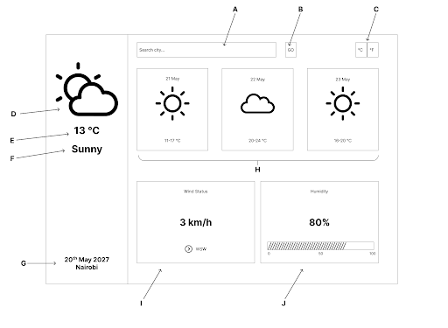

1. Search box that takes the city name
2. Activate city search. Please use Geocoding API
3. Switch between Degrees celsius and Fahrenheit
4. Icon Showing current day's weather icons
5. Current temperature
6. Current weather description
7. Date and Location
8. Weather for the next three days
9. Wind status information
10. Humidity information